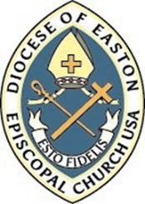

The Episcopal Diocese of Easton
Application for Iona Program (Diaconate and Priesthood)

- Applicant’s Full Name ________________________________________
- Applicant’s DOB_______________________________________
- Sponsoring Clergy_______________________________________
Parish_______________________________________
- Appointment: Discernment with the Bishop - Date:_____________
- Discerning: Priest _____ or Deacon _____
- Information Sheet
- Photograph (recent)
- Brief Autobiography/Spiritual Journey
- Resume
- Baptism Certificate
- Confirmation Certificate
- Education: College/University____________________________
Degree_____________________________________

Applicant Signature:

Signature of Sponsoring Clergy:

Application accepted as complete (initials and date) ________
Reviewed by the Bishop (initials and date) ________
Application accepted _______ or referred ________

